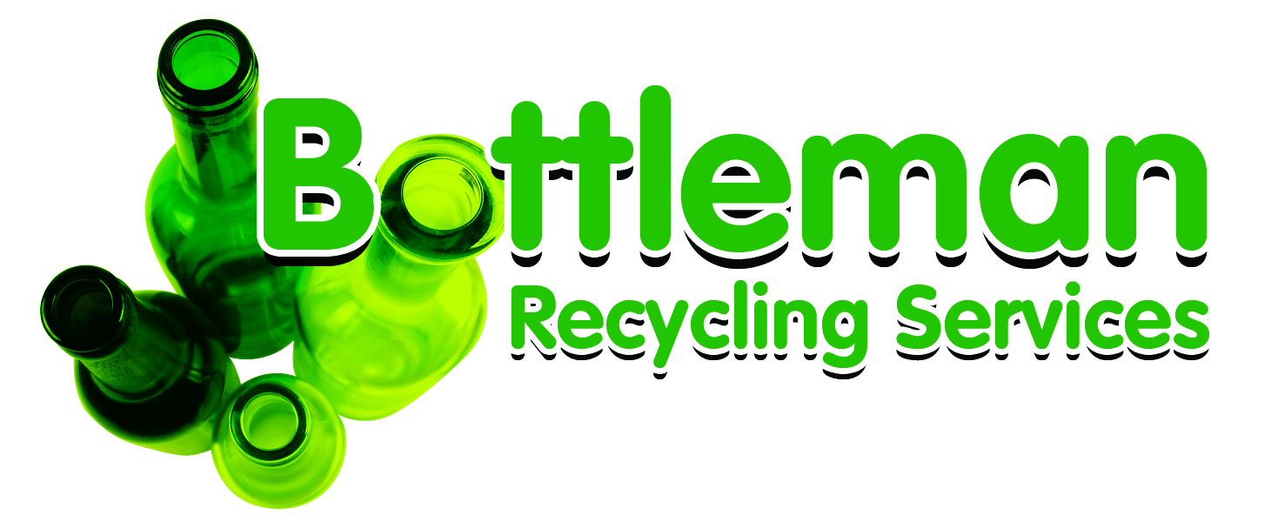
Glass Recycling
Product Data Sheet

Bottleman Recycling Services LTD prides itself in collecting waste plate glass and bottles for recycling for use by glass processors. In order to produce the quality standards demanded by the market, it is essential the right types of glass are collected for recycling and contamination levels are kept to a minimum.
Detailed below are guidelines to help you maximise your financial return through sorting glass into various grades suitable for the recycling process.
Acceptable Glass Cullet
Clear glass | Clear Float, Toughened, Low E, Obscure, Patterned
Mixed glass | Double Glazed Sealed Units upon arrangement, Tinted, Wired, Screen Printed

Please DO NOT return the following types of glass as their chemical composition make them UN-SUITABLE for recycling.
Un-Acceptable Glass Cullet
Safety | Safety backed, mirrors, wardrobe doors, reflectors, optical glass, etc
Fire Resistant | Ceram, Pyrostop, Pyroguard, Pyroshield, Pyrodur, Robax, furnace observation windows, etc
Bora Silicate | Pyrex and other heat resistant kitchen ware, laboratory glassware e.g. syringes, vials, tubes and rods, scientific instruments, lead glass tubes, glass pistons, valve seats, glass beads, etc
Light Fittings | Light bulbs, fluorescent tubes, Halogen bulbs, etc
Domestic Appliances | TV tubes, microwave and oven doors, ceramic and induction hobs, wood burner and multifuel stove doors, etc
General Rubbish | Wood, plastic, cement, building rubble, lead, metal, paper, etc

Contamination
In the event of skips being contaminated with un-acceptable materials, a contamination report will be issued and the waste sent to landfill. The supplier will be invoiced for the cost of land filling based on the rates prevailing at the time of the disposal.

